Can you work this puzzle out?

[](https://www.google.co.uk/imgres?imgurl=http://mes.fm/img/memes/horse-shoe-puzzle.jpg&imgrefurl=http://mes.fm/puzzles/horse-shoe-puzzle&docid=fFMJuFKLIhsEeM&tbnid=AnOCWIavIgoljM:&w=480&h=441&hl=en&bih=592&biw=1242&ved=0ahUKEwjHvcXn1MPOAhULCMAKHfQ2AM4QMwhlKD0wPQ&iact=mrc&uact=8)

[](https://www.google.co.uk/url?sa=i&rct=j&q=&esrc=s&source=images&cd=&cad=rja&uact=8&ved=0ahUKEwiZ2KqSzcPOAhWFPhQKHe3hA6sQjRwIBw&url=http://www.wyegymnastics.co.uk/easy-fundraiser&psig=AFQjCNFZn5iY4JlDvfXDANZV0Rd6UANjPA&ust=1471356688071979)

Support us when you shop.

Login to easyfundraising.org.uk, pick your charity, and then choose your shop, it’s that easy ☺

[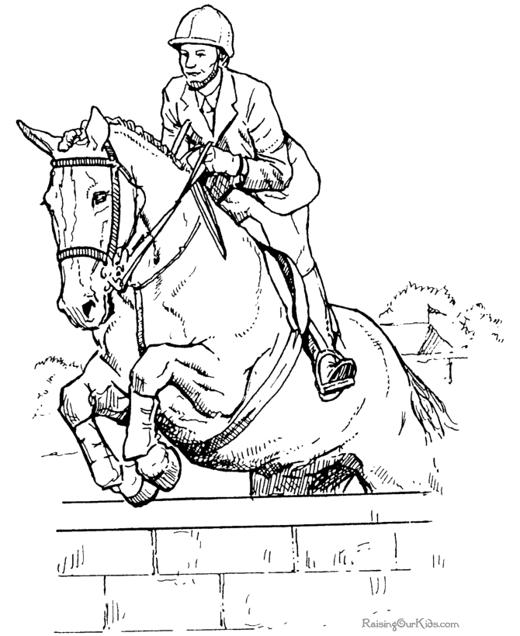](https://www.google.co.uk/url?sa=i&rct=j&q=&esrc=s&source=images&cd=&cad=rja&uact=8&ved=0ahUKEwi1rbWwzMPOAhVTsBQKHSpfCToQjRwIBw&url=http://www.raisingourkids.com/coloring-pages/animal/horse/038-jumping-horse-picture.html&psig=AFQjCNFbnl0WG41I4DaKC6OynWaSoCDVOQ&ust=1471356442412943)

Practice Jumping

This is for Volunteers only as we will need to be assessed to become a jumping group.

I have been approached by several volunteers about jumping and am prepared to start up again if we have enough people willing to participate in this.

Monday mornings seem to be the best day for most people. Thinking of starting from the 22nd August @ 10am, anyone interested please let us know.

The sooner we have done all the practicing the quicker we can get assessed and become a jumping group, which I know many of our riders would love to start doing.

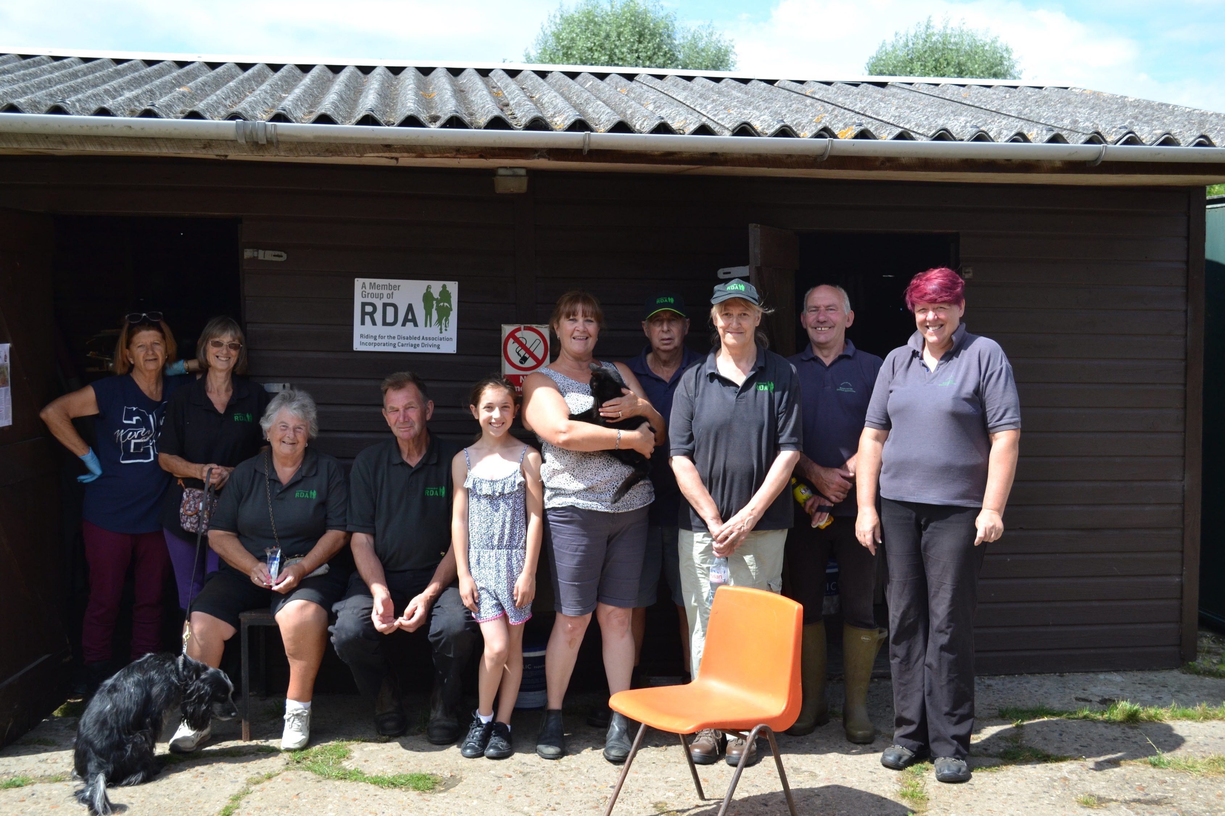

Jan C’s last day with the group. Wishing our lovely volunteer good luck in her new home with a group photo. Hope to see you soon when we travel to Clwyd ☺

**Notes for diary**

24th - Fun day (All day) 1st September – Fun day (half day)

5th Sept – Schools back (Beacon Hill)