

[](https://www.google.co.uk/imgres?imgurl=http://www.planetreads.com/wp-content/uploads/2015/05/Happy-Birthday-wishes.jpg&imgrefurl=http://www.planetreads.com/birthday-wishes-for-18-years-old/&docid=sbpQIGTo3ZBZ4M&tbnid=8W2na1bJk1ySkM:&w=800&h=525&hl=en&bih=592&biw=1242&ved=0ahUKEwiO-8iwrsPOAhVIJsAKHYdUCTY4yAEQMwg-KDwwPA&iact=mrc&uact=8)

Riders

3rd - Nick 7th – Harrison 8th – Karl 29th – James L 30th – Laura G

Volunteers

11th Kerrie

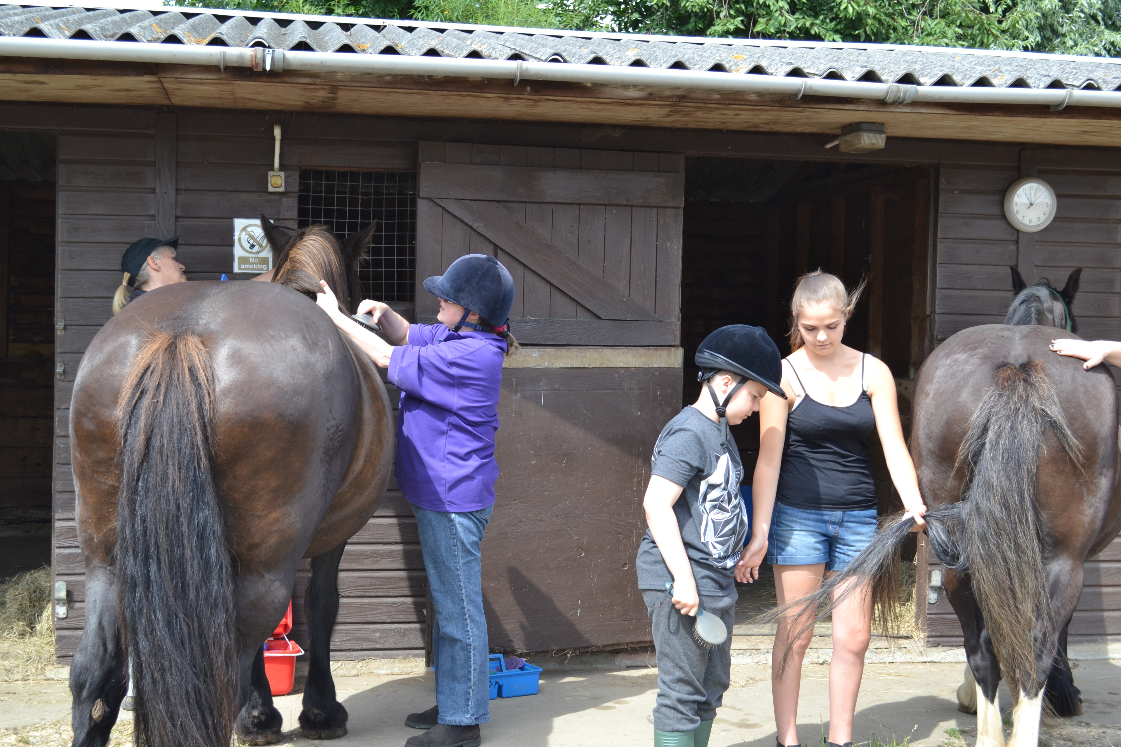

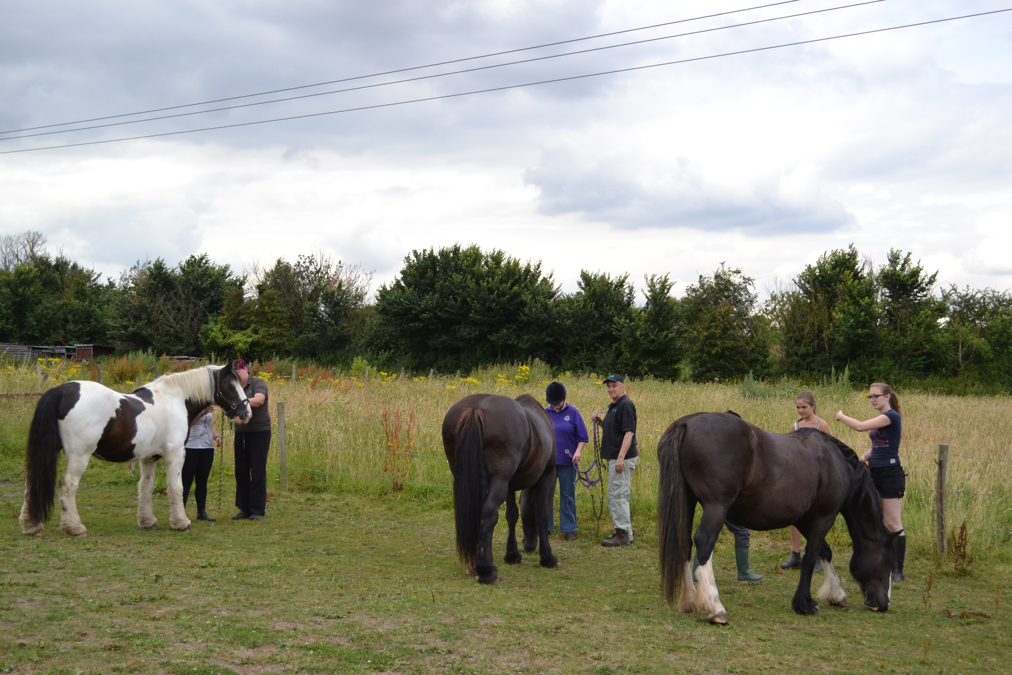

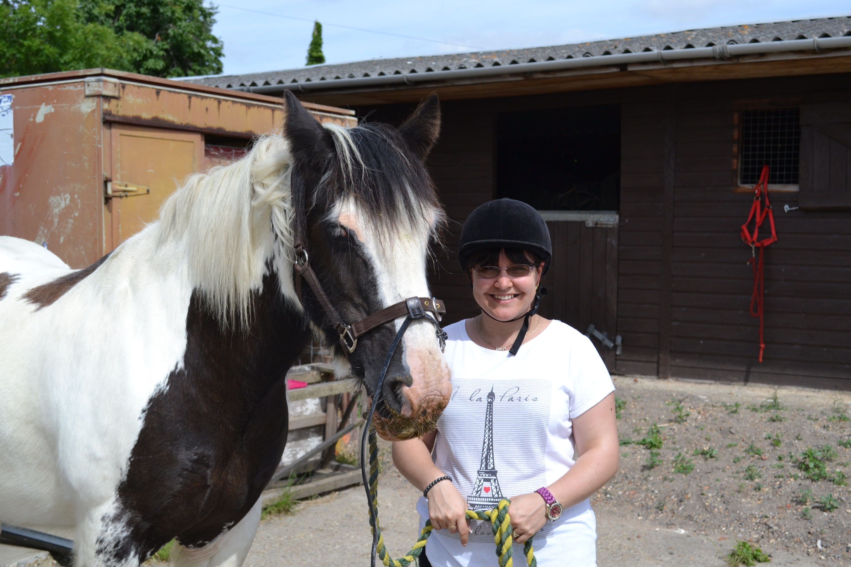

Own a pony day

On the 26th July, we started off with our first pony for the day with three of our riders.

Everyone had a great day, catching their designated ponies from the field, grooming, tacking up and then enjoying a lovely hour’s ride.

After lunch they groomed and tacked up their ponies once again and had another ride over and around obstacles in the field. Once their ride was over they untacked and lead their ponies out to the field and watched them have a well-deserved roll.

What a brilliant day!

Radio Stars!

We had a lovely visit from Sadie Nine from BBC Essex radio, one of our Patrons. Sadie chatted to our riders to find out how riding made them feel and what they got out of riding. She interviewed some of the volunteers and spoke to the parents to get their views.

You can see the video by going to:

www.facebook.com/SadieNineBBCEssex