One for the jokers

A poorly looking horse with a bandage round its head goes into a pub and askes for 4 pints, a vodka and a large whisky. The barman serves him and the horse drinks the lot.

He then looks at the barman and says “I shouldn’t have really drunk all that with what I’ve got”.

Worryingly the barman says “and what’s that then?”

The horse replies “about £2 and a carrot”. ☺

[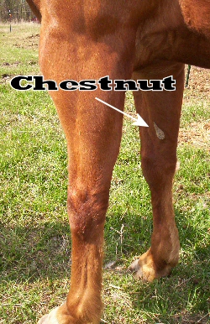](https://www.google.co.uk/url?sa=i&rct=j&q=&esrc=s&source=images&cd=&cad=rja&uact=8&ved=0ahUKEwjWzp3YtIPPAhVJmBoKHb0GDqgQjRwIBw&url=http://www.lemen.com/qa184.html&psig=AFQjCNH6AZfh-Kl9zR3qApKR4nNLolaE5g&ust=1473549146096363)

The Chestnut

The callous type growth on the inside of your horse's leg is called a chestnut. The chestnut is believed to be the remnant of a toe that the horse's ancestors may have had millions of years ago. It is a flaky growth of tough, hardened tissue that serves no function at all for today's horses.

Did you know?

Equestrian in Paralympic Games only consist of Dressage events – individual, team & freestyle.

Teams have 3 or 4 members.

Freestyle is performed to music.

The arena is smaller than the Olympic equivalent and compacted sand is used to facilitate movement.

During competition, the rider may not make a sound, but blind athletes may be guided by sound signals.

The judges are spread around the arena.

The judges evaluate the precision of the movements with scores of zero to one, observing the smallest detail, such as the position of the horse’s head and faults are indicated by a bell.

**Events**

Equestrian in the Paralympic Games consists only of dressage events – individual, team and freestyle. Events-

Equestrian in the Paralympic Games consists only of dressage events – individual, team and freestyle.

Competitors must perform a series of mandatory movements – such as steps, trots and canters – based on the rider’s degree of impairment. Teams have 3 or 4 members.

The freestyle is an event with free movements performed to music, this is where the name ‘horse ballet’ comes from.

Competitors must perform a series of mandatory movements – such as steps, trots and canters – based on the rider’s degree of impairment. Teams have 3 or 4 members.

The freestyle is an event with free movements performed to music, this is where the name ‘horse ballet’ comes from.

Wishing all the Paralympic riders all the best in their classes. These are amazing riders and show that anything is possible and you should never give up when it comes to aiming for your goals in life ☺

[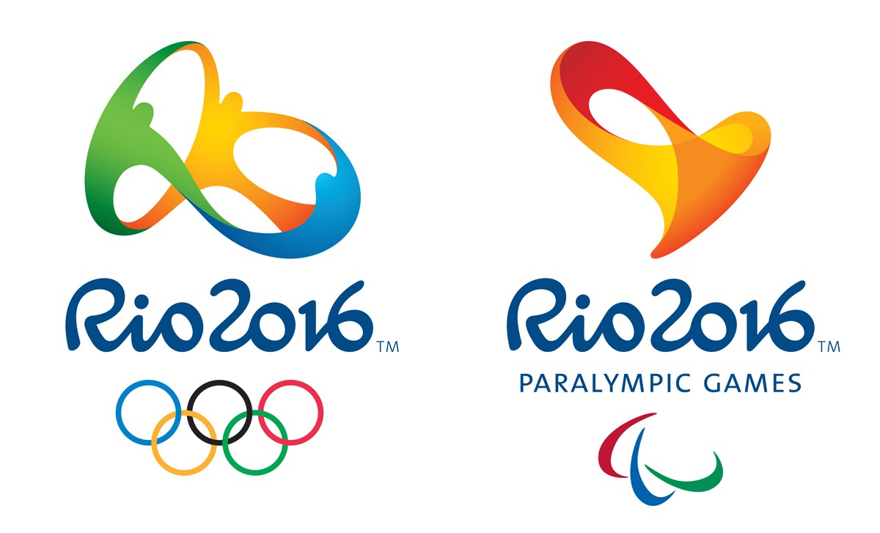](https://www.google.co.uk/url?sa=i&rct=j&q=&esrc=s&source=images&cd=&cad=rja&uact=8&ved=0ahUKEwjljomIo4PPAhVF0xoKHVpNDp4QjRwIBw&url=http://hdfreewallpaper.net/rio-2016-paralympics-wallpapers-images-download/rio-2016-paralympics-logos/&psig=AFQjCNEbptrcdvx0rZ4aYSOugMWINWOzjg&ust=1473544334841801)

Rio Paralympics

