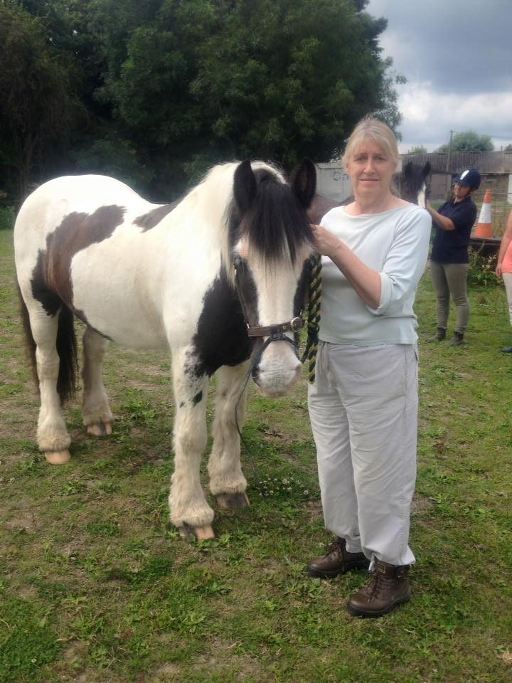
Good luck in your New Home Jan!

We will be saying a very sad farewell to one of our volunteers this month, Jan C. She has been with the group since 2010 and has been a very loyal friend and helper over the years and will be missed by all of us. We all wish her and her family all the very best in her new home and hope to see her when we go to Clwyd on the RDA holidays.
_________________________________________

Support your charity every time you go shopping online, just type in this link and join, and then search your good cause, “Sugarloaf RDA”. You could be raising money for Sugarloaf while shopping, costing you nothing at all. Come on give it a go, it’s so easy!! http://www.easyfundraising.org.uk
Getting hot!! Make sure you have plenty of water now that the hot weather has arrived, we don’t want people dehydrating, also please cover up shoulders, we don’t want people to burn. Some riders have noticed us washing the marks away on the horses when we take the saddles off. We do this to help the horses cool down but most importantly to wash away the sweat marks and dirt that rise to the top of the coat and can become dry and crusty, causing discomfort when saddling up again when dry. Also makes it easier to groom later on.
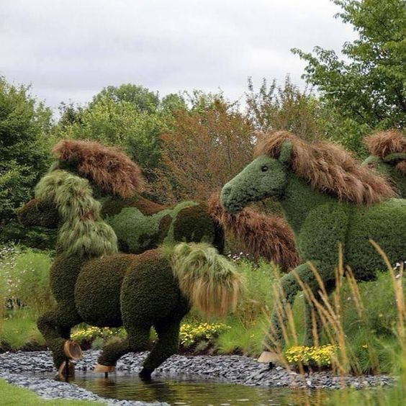
Feeling adventurous?
How about having some designer hedges in your garden. These beauties are wonderful and must have took a considerable amount of time to clip and shape.
Look great if we had something like this for the new stable site when we move over. Anyone want to give it ago?

