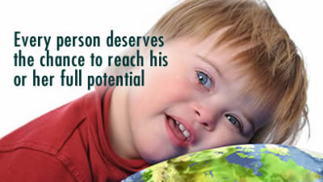

Dates for you Diary

*27/09/2021 – AGM*-

04/12/2021 – Volunteers’ Christmas meal (please see Emma for details)

19/12/2021 – Christmas Party @ Orsett Village Hall 4pm-6.30pm (Bring family and friends) Every one welcome.

**\*27th September 2021 @7pm\***

This is open to all interested in our RDA group. We welcome anyone who would like to join the committee and would like to put an input into what we do or could possibly make it better. Looking forward to seeing you there!

Our current committee are happy to carry on for another year if voted in again, but we know that the treasurer’s position is open if anyone would like to take over from Colette as she would like to stand down and be a committee member only, due to other work commitments. This is being held at:

**Kings Arms Public House (corner of Baker Street) Stifford Clays Road, Orsett, Essex. RM16 3LX**

At the moment our Directors and committee members are:

Group Chair: Mrs Carleen Dallas Treasurer: Mrs Colette Knight Secretary: Miss Christie Stimson

Committee members: Mrs Joyce Wanley Mrs Lisa Walsh Miss Emma Dallas (Group Safeguarding officer)

“My Ability is stronger than my Disability”

------------Theresa Sheridan

Reopen for business!

“Onwards and Upwards”

The last 3 years has been a real big struggle for us as a group, what with the shut down for 2 months in 2019 when the yard had several horses catching the strangles virus, an awful virus that can sometimes be fatal to horses and is easily spread from horse to horse. All horses had to be quarantined and no one was allowed on the yard. Unfortunately several of our riders and volunteers were looking forwards to attend the regional show in Cambridge hoping to get through to the Nationals later on in the year but we had to cancel right at the last minute, losing money for transport that had already been paid for.

Then 2020, what can I say? This year had a knock on effect with the Coronavirus pandemic, with whole country in lockdowns and businesses shutting down, many people losing their loved ones and being very ill, people losing their jobs. It’s fair to say nearly every one of us has known someone in this situation. We did reopen for a short time until just before the second lockdown, when unfortunately two volunteers caught covid-19 and we decided to not take the chance and put vulnerable riders at risk. I was taken aback but our riders’ families who were very understanding and supportive of our decision, thank you. In all we have been shut for 15 months, including 2020 and 2021, with no money coming in and still having to pay for the groups horses.

16th September 2021 we reopened once again and how wonderful it was to see our riders back. Again a little sad to have lost some of our past riders due to their disability deteriorating after having missed the physio much needed through riding with us. We have noticed this with some of our riders being very stiff when getting on the horses this week. Hopefully now this is the start for us to look forward and not look back, “Onwards and upwards”.

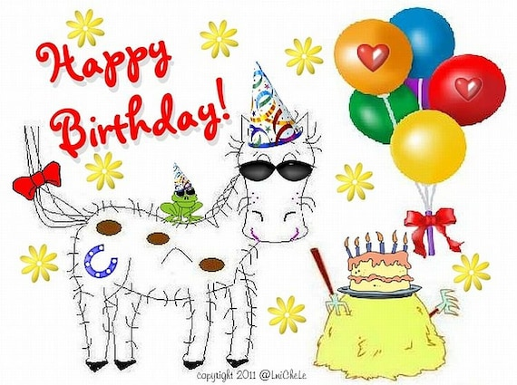

Riders: 5th- Riley M 8th - Linziann C 22nd - Alby D

