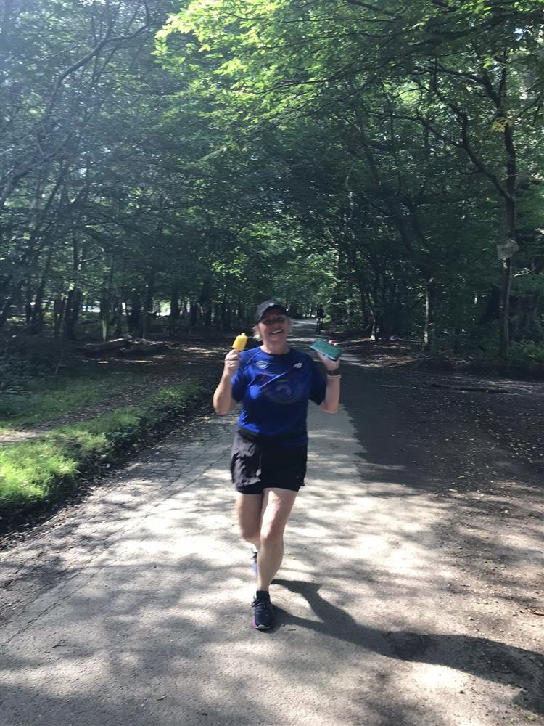

**Colette’s running the London Marathon for us!**

I would like to introduce you to Colette Knight, she is one of our riders mum and has been a member of our groups committee for quite some time, starting off as Chair and is now our Treasurer.

To top it all she has decided to run the London Marathon in aid for Sugarloaf, which is utterly amazing!

Please give her your support by going to and giving whatever you can afford:

www.justgiving.com/fundraising/colette-knight5?

We are still desperately looking for more volunteers to help out on a Tuesday morning 9-12:30 if you know anyone who would like to volunteer with us, please ask neighbours and friends, thank you

A couple of horse Facts:

Horses love carrots and apples but did you know that the also like bananas too and can even eat the skins.

Horses that live by the sea often eat seaweed called “Kelp”.

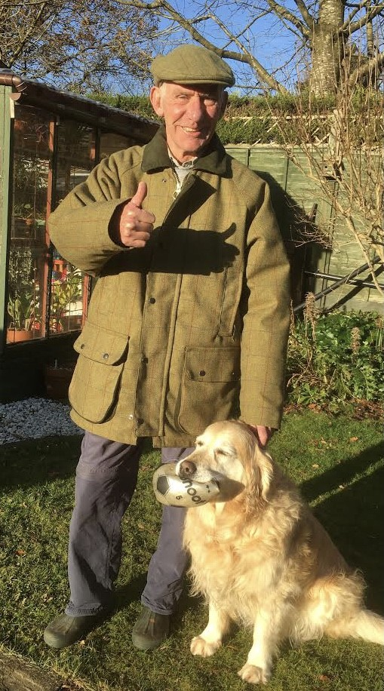

**Good luck in your new home!**

As many of us know at Sugarloaf’s long standing coach, Laurie, has now moved away to start his new life with his wife in Oxfordshire. He will be greatly by us all but we do wish him all the best. We had a small whip round between us and brought him a lovely jacket as a leaving present.

Laurie modelling his new jacket

**Welcome to our new volunteers**

I would just like to thank all our current and new volunteers for their attendance at the training days I put in place, ready to reopen again. You are all a lovely bunch and I very much look forward to working with you all. ~~~~~~~~~~~~~~~~~~~~~~~ Carleen ☺

Delboy checks out his new rug

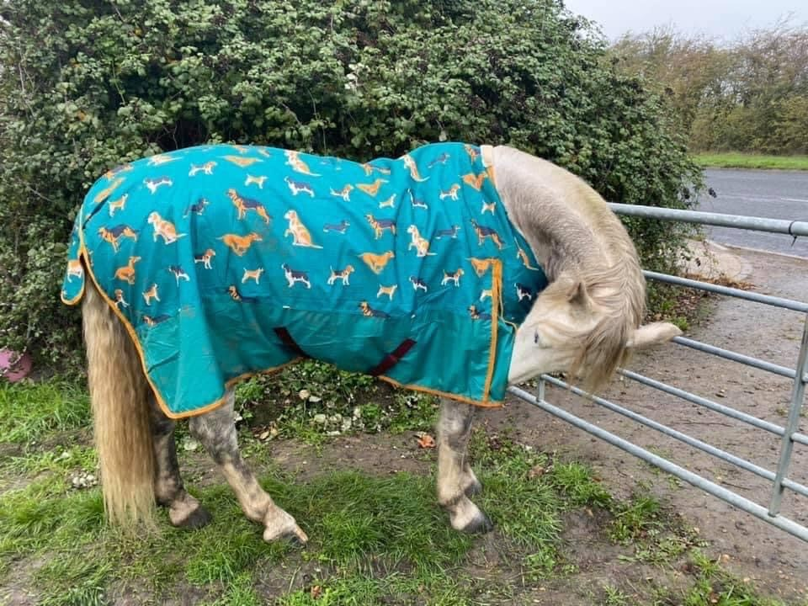

Bath day for Bess

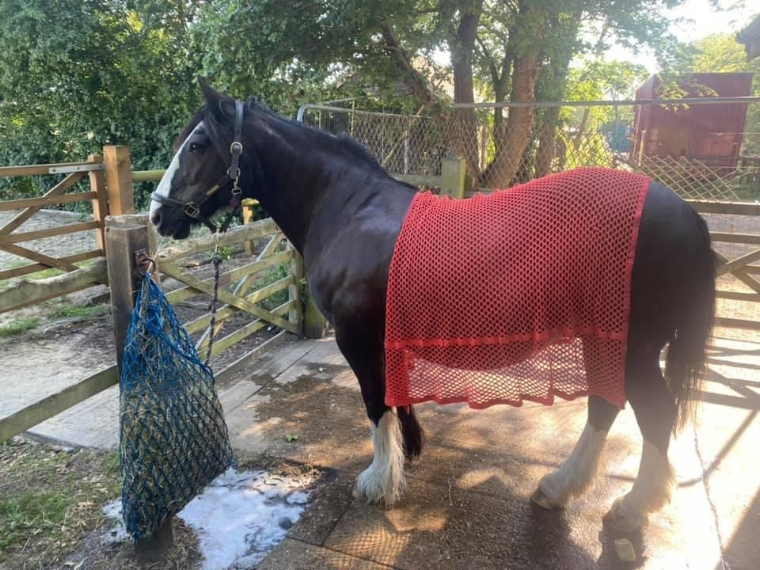

During lockdown our horses still needed to be looked after and cared for and our volunteer Emma has done a great job doing this.