APPLICATION FORM FOR A NEW VOLUNTEER AT A MEMBER GROUP
(PLEASE USE BLOCK CAPITALS AND RETURN TO GROUP ADDRESS)
To be completed by Group before being given to applicant
GROUP NAME | Sugarloaf RDA
CHARITY NO | 1154445
CONTACT NAME | Carleen Dallas
ADDRESS | C/O 35 Chafford Way, Grays, Essex. RM16 2ED
EMAIL | rdasugarloaf@gmail.com
TEL NO | 07936 031086/07854747754

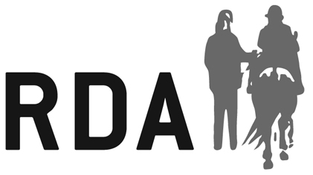

All the information you provide will enable us to contact you in relation to your volunteering activities with RDA. This may include sending you important information, which relate specifically to your volunteer role.

1 YOUR DETAILS

Full Name |  | Gender
Date of Birth |  | Age
Address
Email Address
Telephone Number
Mobile Number

2 SPECIFIC INFORMATION ABOUT YOU
The information in this section will be used to help us learn a little more about you, understand your needs, and ensure we are able to place you in a suitable volunteering role at the group.

Equine experience

Experience volunteering/working with people with disabilities
Other skills and professional qualifications
Do you consider yourself to be disabled?
Is there any information that we may need to consider when placing you as a volunteer to ensure you have a positive experience? (Medical conditions, impairments, specific needs, accessibility requirements, allergies etc.)

- EMERGENCY CONTACT DETAILS
If you become a volunteer with us it’s important we know who to contact in case you are injured or become ill while volunteering.

Full Name
Relationship to you
Telephone Number

By ticking this box I confirm I have consent of the individual listed above to be contacted in the case of an emergency during the course of RDA activities.

4 REFERENCES

We request all volunteers provide two references to support their application. These people should not be related to you and should be someone you know in a professional capacity where possible.

It is our policy to take up all references.
Full Name
Address
Email
Phone

Full Name
Address
Email
Phone

5 DECLARATION

I consent to an enhanced disclosure check being made (if applicable), will abide by the group’s policies and procedures and confirm that the information provided on this form is correct. I accept that failure to disclose information or subsequent failure to conform to the group’s Safeguarding Policies & Procedures may result in possible disciplinary action.

As part of the checking procedures, you are advised that the Group reserves the right to make reference to the Local Authority Social Services Department and Police Records to verify information given on this form, when it is submitted or at any time in the future.

NB: It is the duty of all Group personnel, coaches and volunteers to report any conviction involving children.

By ticking this box I give consent to my photograph being taken during RDA activities for training and/or publicity (including websites, social media, newsletters and marketing materials for the group and RDA UK). I give this consent acknowledging the photos will not be given to a third party without my explicit consent.

Signature |  | Date:

If you are under 18 this form must also be signed by a parent or guardian.

Signature |  | Date:

The information provided on this form will only be used for the purposes stated above in relation to RDA volunteering activities.

RDA Group Use: Date Application Received:
Is application approved or declined? (delete as applicable) APPROVED / DECLINED

APPLICATION REVIEW DATE (At least every 3 years):

