19th December 4-7pm at Orsett Village Hall

Mill Lane, RM16 3HB

The horse, did you know?

An adult horse’s brain weights 22 oz. about half that of a human.

The average horse's heart weighs approximately 9 or 10 pounds.

Everyone welcome! Friends & families. Entertainment, raffle and much, much more. Bring your own drinks drinks.



Sugarloaf RDA

Dates for your Diary

4th December @ Sandmartin, Chafford Hundred (5pm)- Volunteer Christmas Meal (please could you make sure you have given all your deposits in to Emma, and please let her know the choice on menu asap).

7th, 9th and 11th December – NO RDA (coach on holiday)

19th December 4-7pm – Our Annual Christmas Party @ Orsett Village Hall. (Riders, volunteers, families etc)

I’d like to thank everyone in their support of now paying riding money straight over to our bank. This has had some hiccups but I’m sure once everyone has got the hang of it, then things will start to run smoothly.

If any rides are cancelled through illness or weather this will be rectified with your next monthly invoice, but please if there are any problems let us know and we can look into the problem and hopefully sort it out.

As we have a lot of new riders that have joined us, I would just like to state that we do like at least 24 hours’ notice if someone cannot ride otherwise you will be charged. Discretion will be used for certain situations.

Thank you to everyone that has helped raise money for the new horse, we were taken aback by the generous donations. So far we have raised £1,270 on our Go fund me page ☺

We will hopefully be looking for a new horse soon but at the moment we have been lucky enough to be using our yard owners horse “Trixie” who has taken to RDA very well indeed.

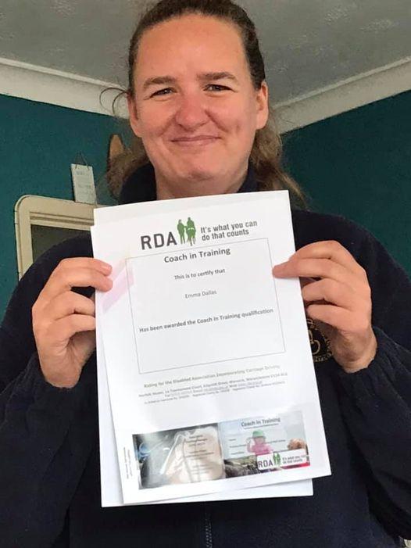

With current prices continuing to rise we have had to make a little alteration to the size of the toilet hoping to cut back on our expenses for the group. This toilet is a normal size rather than a disabled toilet and hope it doesn’t affect anyone that needs to use it, whether rider/parent/carer or volunteer. Please let us know if there is a problem and we will see what we can do.

Well done Emma now receiving her Coach in training certificate. You have worked hard for it around taking care of the horses.

Emma also passed her driving test on the same day and I’m sure that’s going to help her considerably.

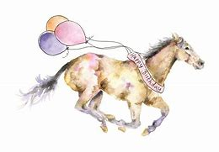

Riders Birthdays

Jessica 8th Alice 11th

Volunteers Birthdays

Emma D 4th