November 2021 Sugarloaf newsletter page 2 Charity no. 1154445
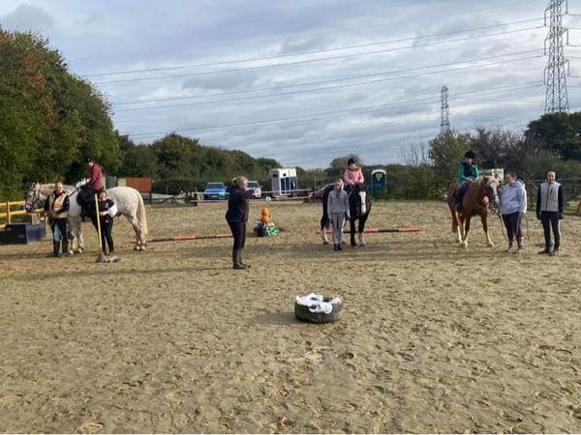
Had a brilliant time on Saturday playing games with a Halloween theme. Not completely sure that everyone was happy with the giant spiders but had plenty of smiles and everyone became very competitive.
Well done everyone with their steering around the obstacles. Plus well done to Jenny, Kara and Nicky for being on team as the stand-in horse (though I did see a little cheating going on ).
Looking forward to the Christmas themed one next.
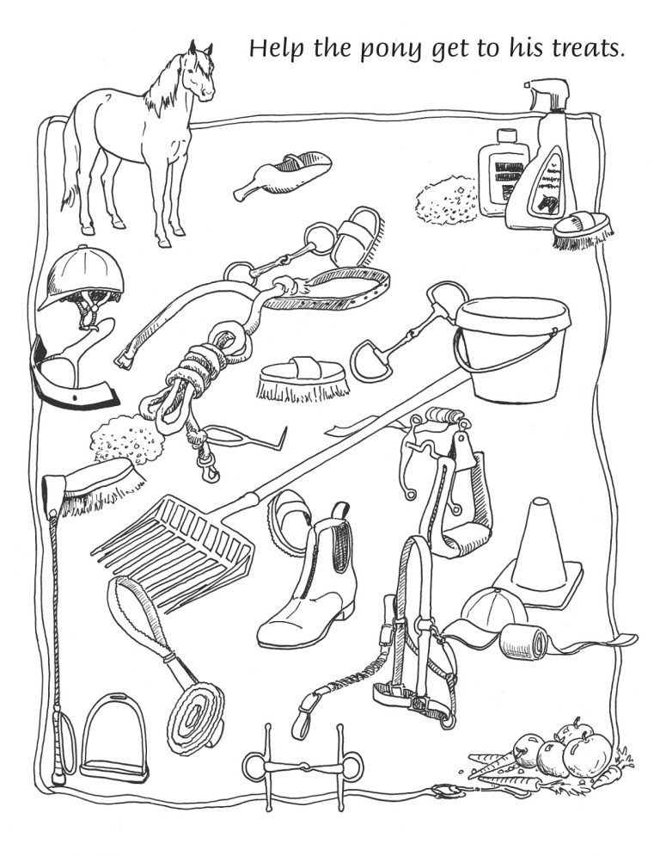
Can you spot the horse items and colour them in?
- Riding hat
- Hoof pick
- Lead rope
- Riding whip
- Sponge
- Loose ring snaffle Bit
- Bucket
- Jodhpur boot
- Body brush
- Sweat scraper
- Stirrup (American)
- Shavings fork
- English stirrup
- Apples and carrots
- Cone
- Horse
- Bandage
- Cap
- Stirrup leather
- Rubber curry comb
- Shedding blade
- Plastic curry comb
- Dandy brush
- Food scoop
- Fulmer snaffle bit
- Tack cleaner & sponge

