

On the 24th of August and 1st of September we had our fun day shows. Unfortunately there are no photos to show but it was an amazing couple of days.

There were obstacles set up to show the judges, Kathy and Joyce, all that our riders are capable of doing with help and completely independently.

It started off with riding their horses along a wiggly road, then picking up a ball and with the same hand throwing it into a bucket on the opposite side. After halting and then riding along the set out bridleway they encountered the scary sheep (kept falling over due to the wind☺). They guided their horses around the small numbered bushes and then ducking under the trees, to stopping at the post box to post a letter. After making their way over the fallen trees they put an egg in a basket and circled the duck pond, giving their pony a long rein along the track they finished the course by stopping at the farmer, praising their horse and receiving a lovely rosette.

Horses, riders, volunteers and judges done a marvellous job, you all worked hard in the hot weather. Thank you all for all the hard work in making it a couple of very special days.

Our deepest Condolences

We would like to give our very heartfelt condolences to one of our riders and his lovely family after losing their nearest and dearest to cancer.

Mark was a wonderful man and his funeral was a beautiful memorial to him to say goodbye.

Thank you Lynn for the wonderful flowers you designed for the group and to everyone who chipped in to pay for them. Beautiful!

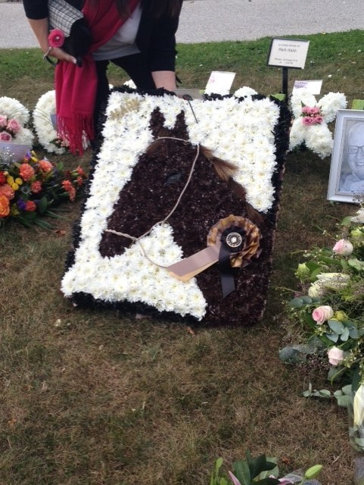

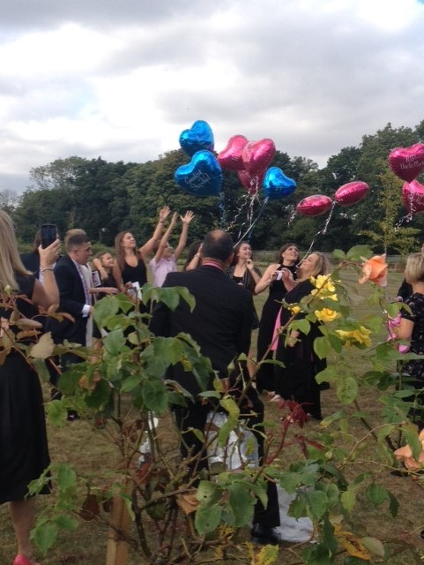

[](https://www.google.co.uk/imgres?imgurl=http://www.todaytip.net/wp-content/uploads/2013/11/excellent-thanks-messages-for-birthday-greetings.jpg&imgrefurl=http://www.todaytip.net/excellent-thanks-messages-for-birthday-greetings/&docid=eOYvxI-Md-euSM&tbnid=lwXHyPPRLFuORM:&w=400&h=400&hl=en&bih=651&biw=1366&ved=0ahUKEwiWmc7t8ILPAhUqDcAKHbXjCcc4yAEQMwhHKEUwRQ&iact=mrc&uact=8)

Riders

1st- Sally 3rd – Chloe 17th - Alexis 22nd – Alby 23rd – James P 25th –Alfie

Volunteers

28th – Abby 30th - Laurie